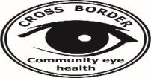

Cross Border Community Eye Care Program Free the Oppressed Report – January, 2024
First of all, I would like to thanks God for his compassion, unconditional love and he has been chosen us as his servant to help the people in needed. If is not by the grace of God, we could not make it to 2024. In the previous year, many innocent people died from war, many lost their love one and many had to flee from war but till now it is still happening. However, we pray for peace and love for Burma.
In January 7 to 15, 2024 we organized the eye mission at K1, Toe Tet Kee New Clinic as planned everything went well. On this mission Mg Mg and K1 health care leader were a host. In 9 days, we screened patients close to 400 and 115 patients underwent eye surgery. Unfortunately, we had to make an appointment with over 50 patients for the next mission due to lack of supply and inadequate time. In the next few months hopefully, we could have the second mission to cover all patients in the area.
Next, I also would like to tell the situation of the new clinic. The new clinic has the small Out Patient Department (OPD) but had not pavement yet so we had to working on wooder floor nevertheless it was a blessing for the patient to come and receive the treatment. It also has the others three building for In patient Department (IPD). The basic need for the new clinic now is clean toilet and clean water. As it is the new clinic, there are a lot of needed but we are praying for a new clinic and everyone who take part in administration, construction and all their networking.
The second mission it was at Kler Mu Clinic from 15 to 23 of January, 2024. In 9 days, we screened patient close to 200 and 50 patients underwent surgery. We didn’t receive a lot of patients compared to the previous year because the fighting is happening at K3 and it stops patients to come for treatment. Another biggest problem is the transportation. However, during the difficult time many patients still came for treatment they were very happed to see us. Then, we also would like to thank Kler Mu Clinic for warmly welcomed us, we felt blessed to have them and collaborate with them.
Last but not least, we are thanks to FBR team for supporting our mission. Your time, work, energy and a heart of loving others benefit to every person who need helped. In the future, we wish to progress the assistance and helped others as possible. The details of the treatment and money expenses on the mission show below.
) The box below is indicating money needed for the mission
The box below is indicating money needed for the mission January 2024
(1)-Table of schedule
Number of IOL | Location | Date start Consultation
100 | K1, Toe Tet Kee New Clinic | 7 To 15 January, 2024
100 | K5,Kler Mu Clinic | 15 To 23 January, 2024

No | Equipment Name | Amount
1 | Supply (Equipment) Need | 245,680 Baht
2 | Transportation Need | 32,000 Baht
3 | Pay eye medic (Each 3,000 Baht ) 10 Medic for this mission | 30,000 Baht
4 | Need for Food | 30,000 Bath
 | Total | 337,680 Baht

Total amount of money spends on eye mission from January 2024
No |  |  | Amount
1 | Buy Eye Equipment |  | 251,670 Baht
2 | Transportation |  | 30,430 Baht
3 | Pay Eye Medic ( Each 3,000 Baht) for this Mission |  | 35,000 Baht
4 | Food |  | 20,430 Baht
 |  | Total | 337,530 Baht

(2)- K1 Toe Tet Kee New Clinic and K5 Kler Mu Clinic In this mission we screened patients and the detail information is showed below.
- Total Eye Screening 600
- Total Cataract operation 165
- Total Giver Eye Glass 385
- Total Ear sound device 6

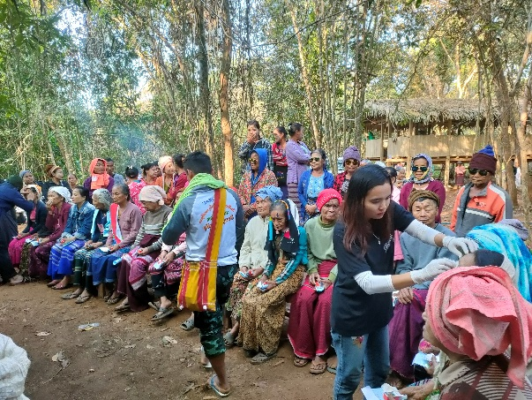
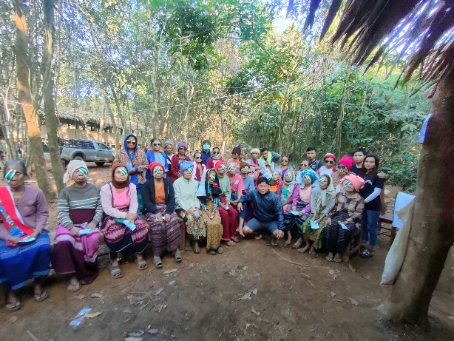
Toe Tet Kee new clinic
Group photo with patients
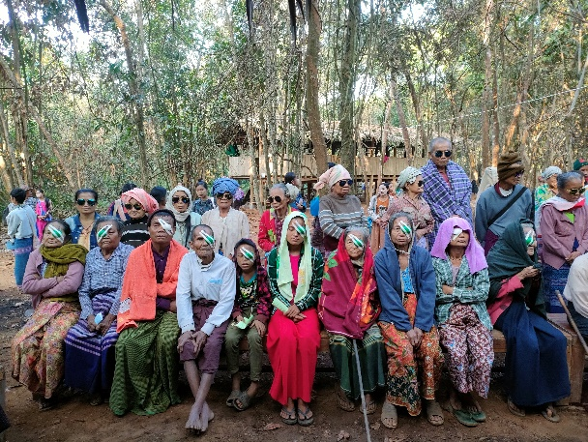
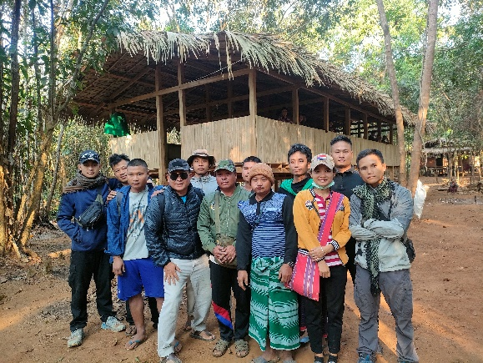
Group photo with Mg Mg and K1 health care leader in front of OPD and IPD
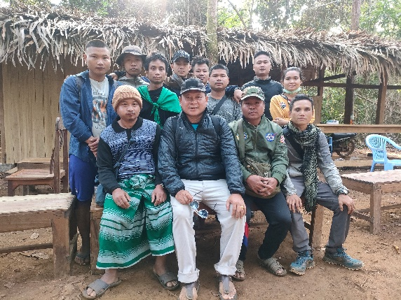

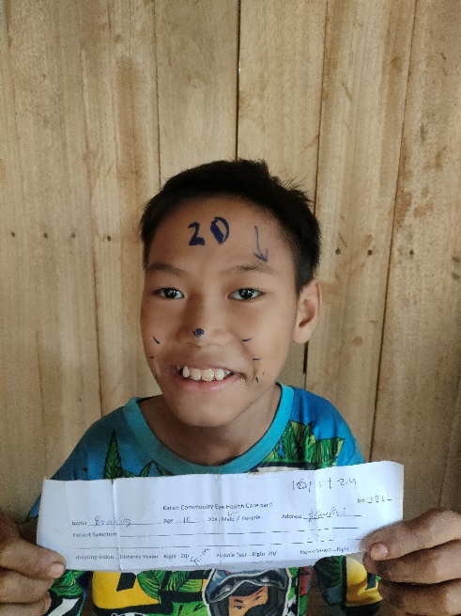
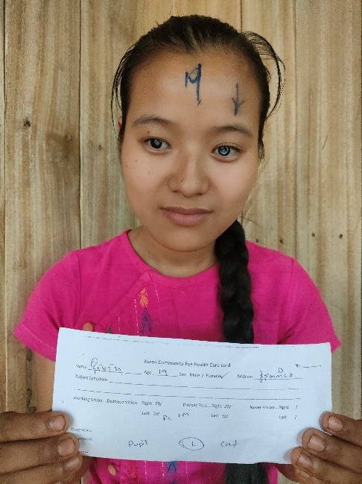

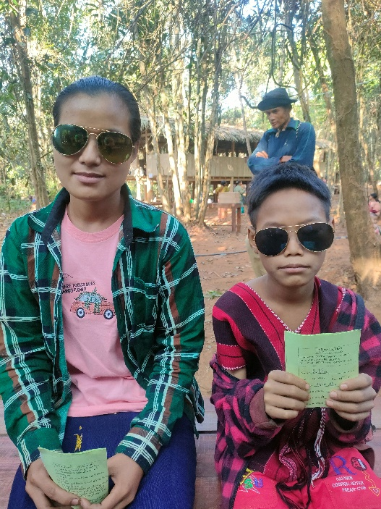
17 years old Naw Ma Aye experienced childhood cataracts since she was 10 years old. After the treatment, she could see again and brought the smile to her family.
10 years old Saw Klaw Kay experienced childhood cataracts since he was a little.

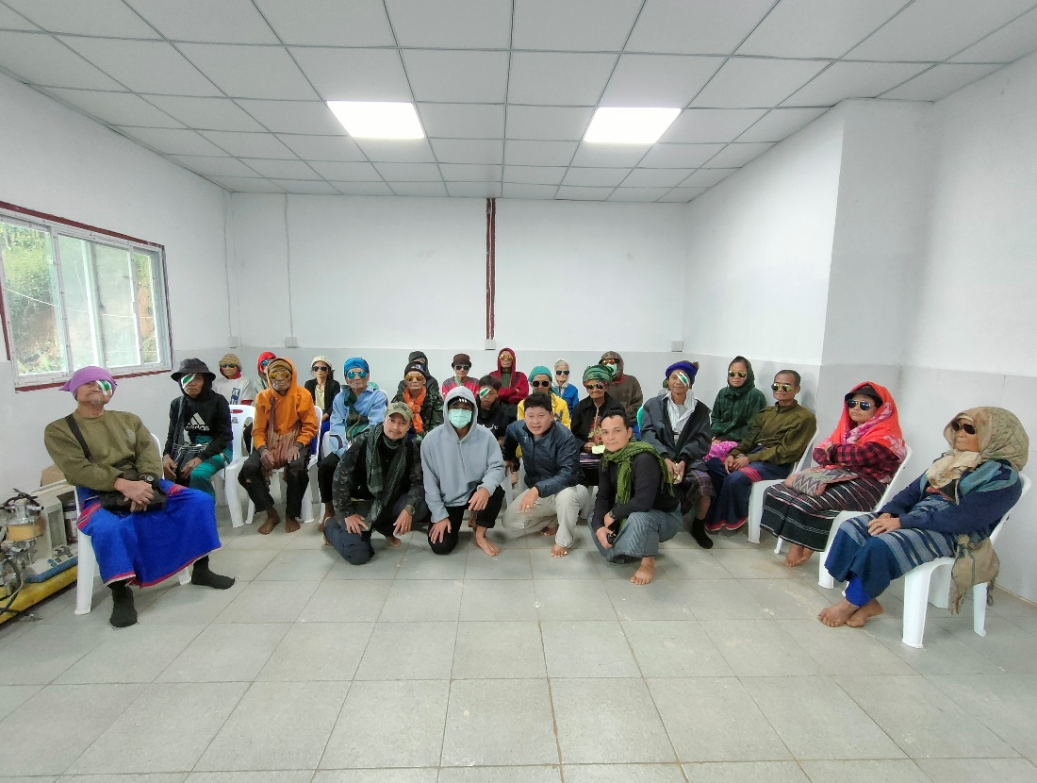
Kler Mu Clinic
Group picture

